Theory of Translation & Interpretation. Intercultural and Interlingual Communication and Theory and Practice of Translation & Interpretation in Professional Communication

Qualification
Training profile

Language of instruction

Commencement date
Mode of study
Master
Theory of Translation & Interpretation. Intercultural and Interlingual Communication (specialization: interpreting)
Theory and Practice of Translation & Interpretation in Professional Communication (specialization: translation)
Russian; some subjects are taught in English; linguistic disciplines are taught in foreign languages September 1

On-campus (2 years)

Where will I study?

In the high-tech classrooms for simultaneous interpretation and translation at the Caspian Higher School of Interpreting and Translation, Astrakhan Tatishchev State University

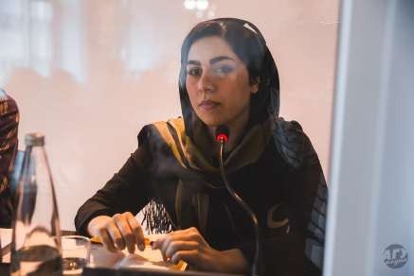
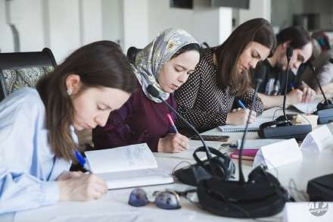
What will I study?

Simultaneous interpreting
UN languages
Terminology
Modern translation technologies
International organizations,
Parliamentary procedures and conference terminology
Asian languages
Consecutive interpreting
Practice of remote interpreting
IT in translation

Who will teach me?

Interpreters and translators
- professors of the Caspian Higher School of Interpreting and Translation, and Russian and foreign partner universities
- interpreters of the Ministry of Foreign Affairs of the Russian Federation, interpreters of leading enterprises of Astrakhan Region

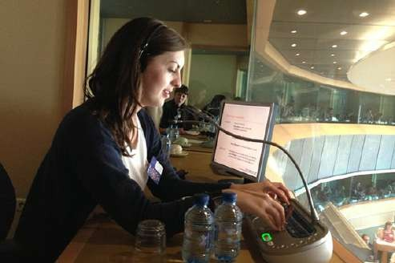

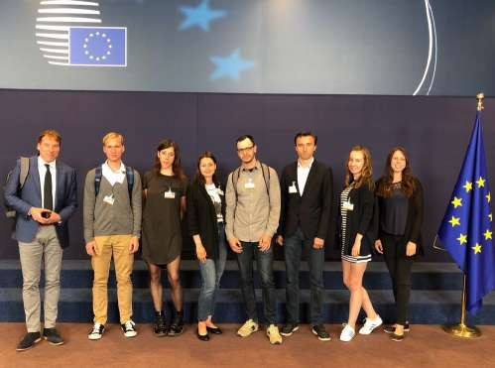
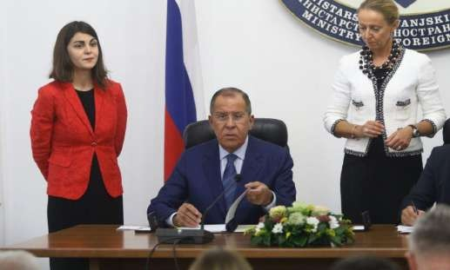
Where will I work?
Where will I intern?

Ministry of Foreign Affairs of the Russian Federation, Moscow

World Intellectual Property Organization, Geneva

UN Office in Vienna, Austria

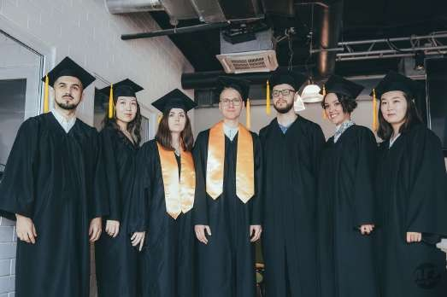

Our graduates work in major Russian and foreign companies. 80% of our students work in T&I

We invite everyone to visit our school online, learn about the opportunities provided by our programs, and ask questions of interest.
Looking forward to receiving your applications at caspianschool30@gmail.com or perevod.astlink@gmail.com

Graduate qualification work as a project:

Our students have an opportunity to write a master's thesis in cooperation with a real customer and a prospective employer: students can choose to contribute to the terminology bases of the World Intellectual Property Organization or ROSPATENT.

